Name : Zuha Irfan
Roll No : 2023-BSE-073
Subject: Cloud Computing
Semester & Section : V-B
Lab :10

Task 1 — GitHub CLI Codespace Setup & Authentication
- task1_gh_install.png
- task1_gh_auth_login.png
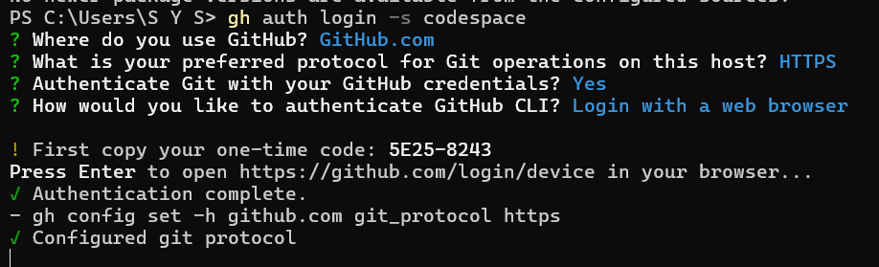

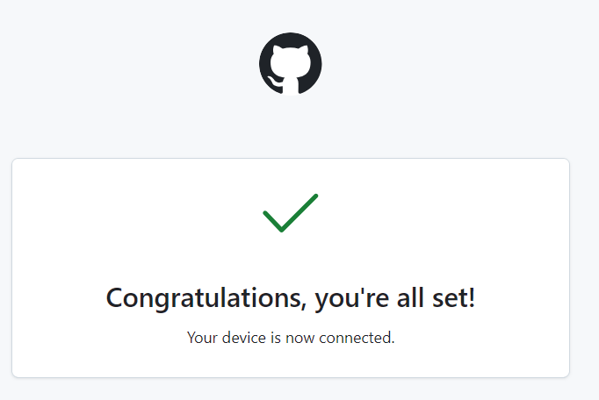

- task1_codespace_list.png
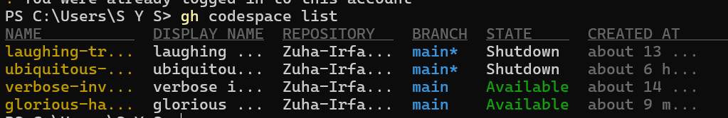

- task1_codespace_ssh_connected.png

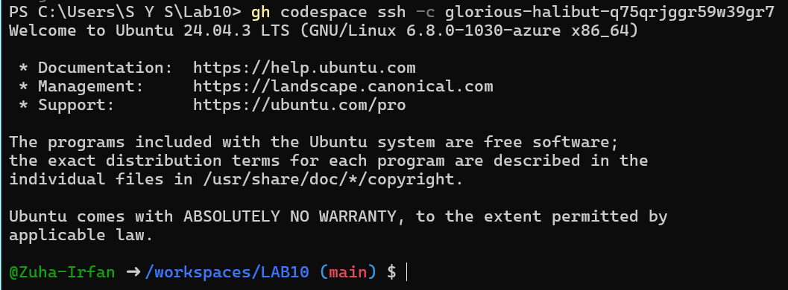

Task 2 — Install AWS CLI, Terraform CLI, Provider Setup
- task2_aws_install_and_version.png
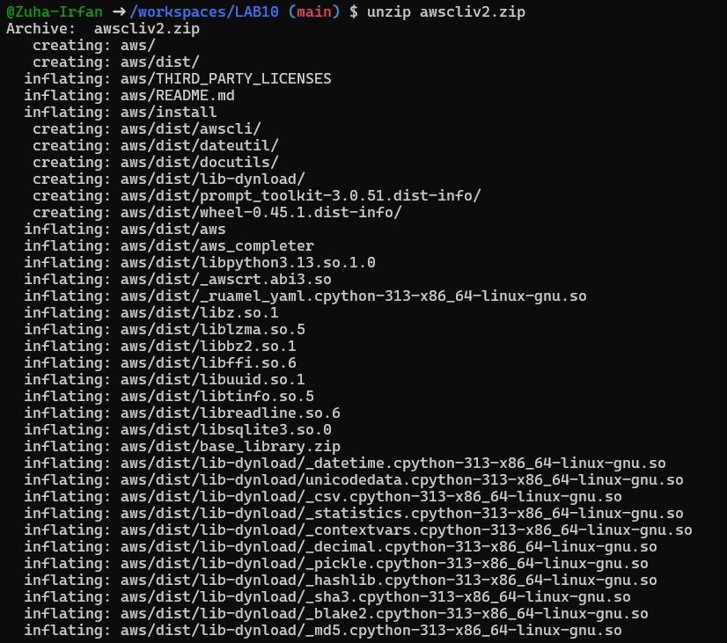

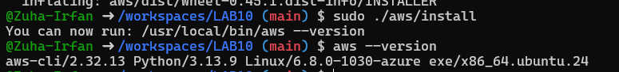

- task2_aws_configure_and_files.png

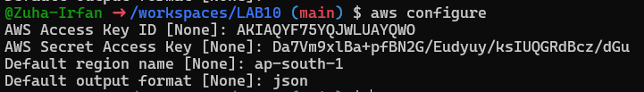

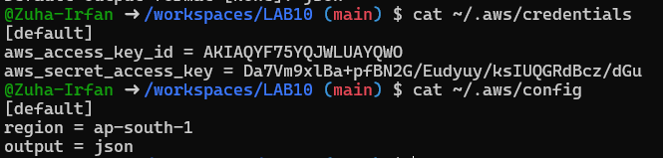

- task2_aws_get_caller_identity.png
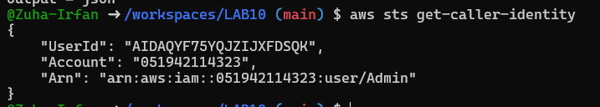

- task2_terraform_install_and_version.png
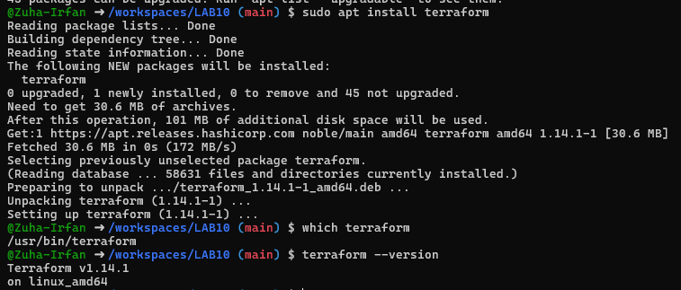
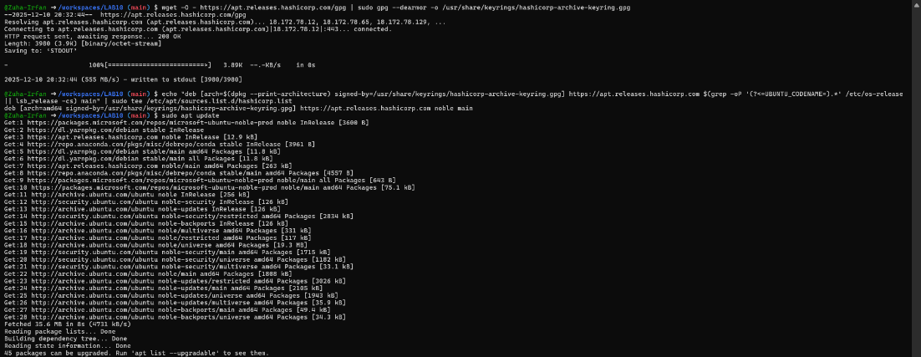
- task2_provider_file_creation.png

- task2_provider_block.png

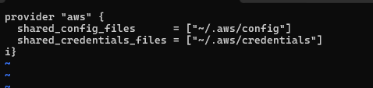
- task2_vim_save_main_tf.png
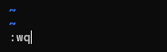
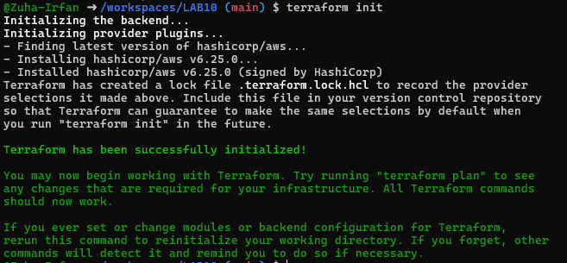
- task2_terraform_init_output.png

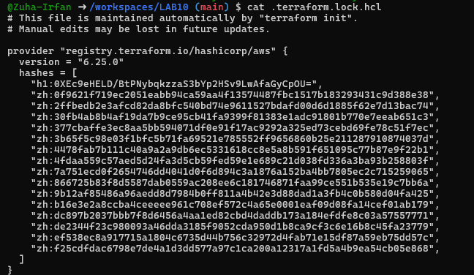
- task2_terraform_lock_hcl.png

- task2_terraform_dir_ls.png

Task 3 — VPC/Subnet Creation, Initialization, Verification
- task3_main_tf_resource_add.png
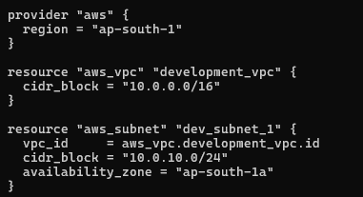

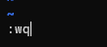

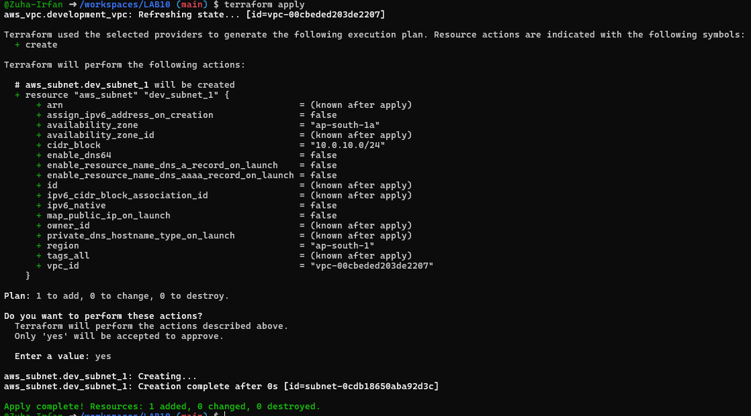
- task3_terraform_apply_vpc_subnet.png

- task3_aws_cli_verify_subnet.png
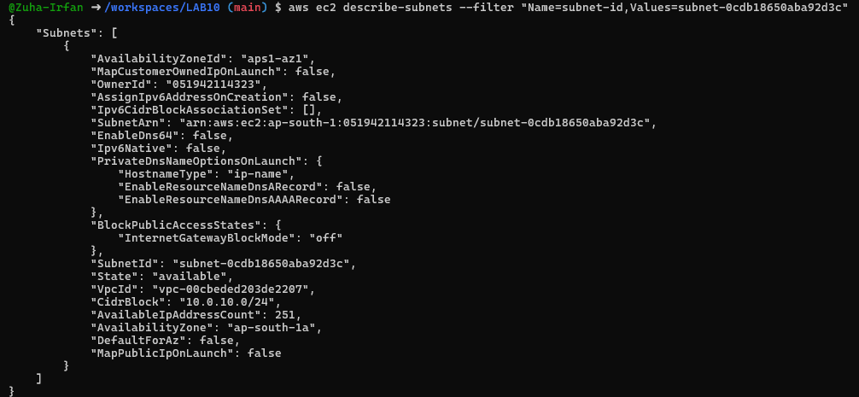

- task3_aws_cli_verify_vpc.png

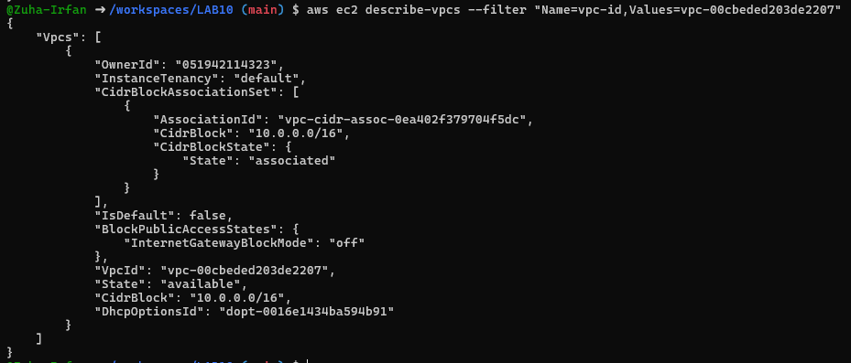

Task 4 — Data Source, Targeted Destroy, Tags
- task4_main_tf_datasource_resource_add.png
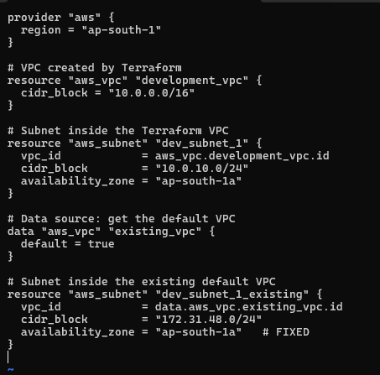

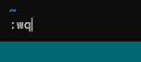

- task4_terraform_apply_datasource_resource.png

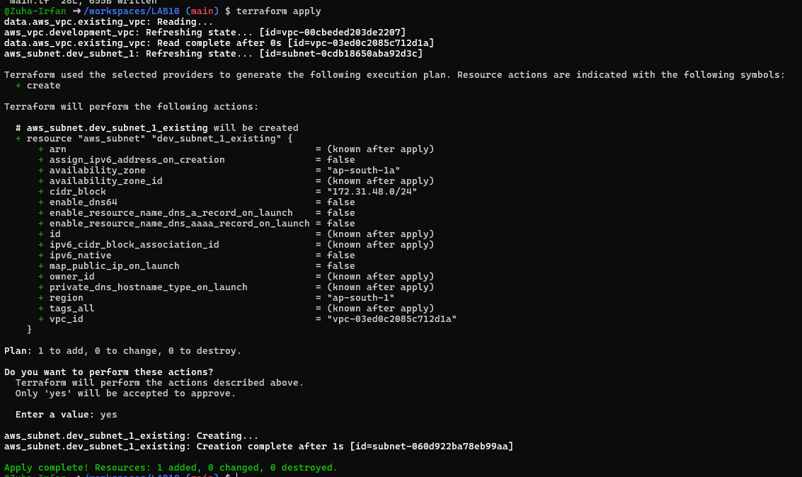

- task4_terraform_destroy_targeted.png
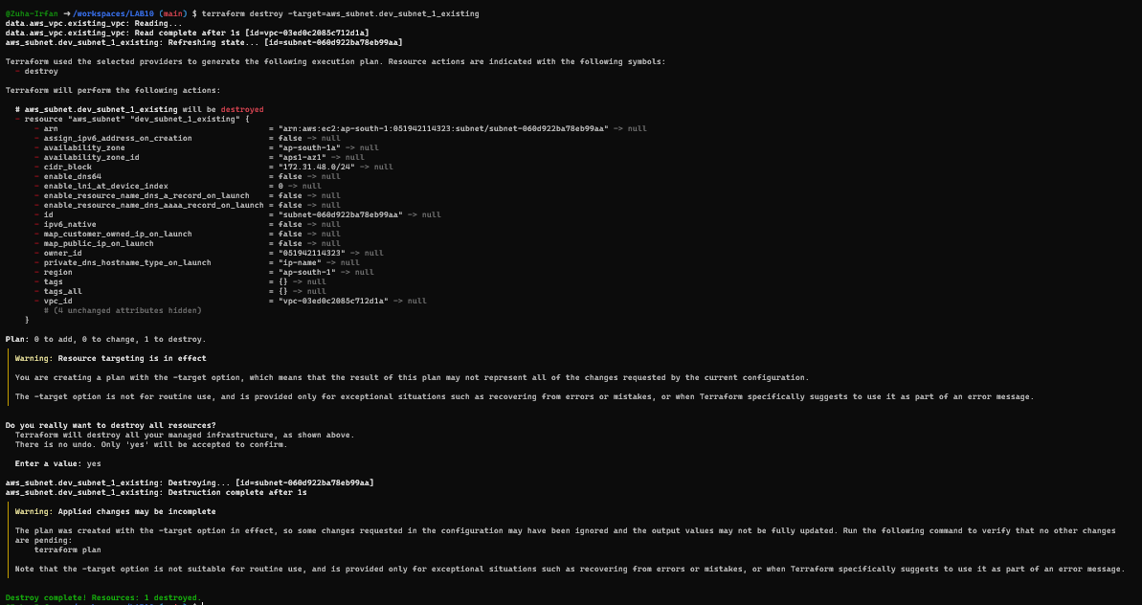
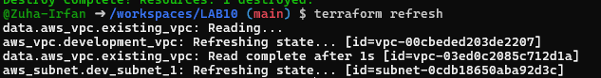
- task4_terraform_refresh_state.png

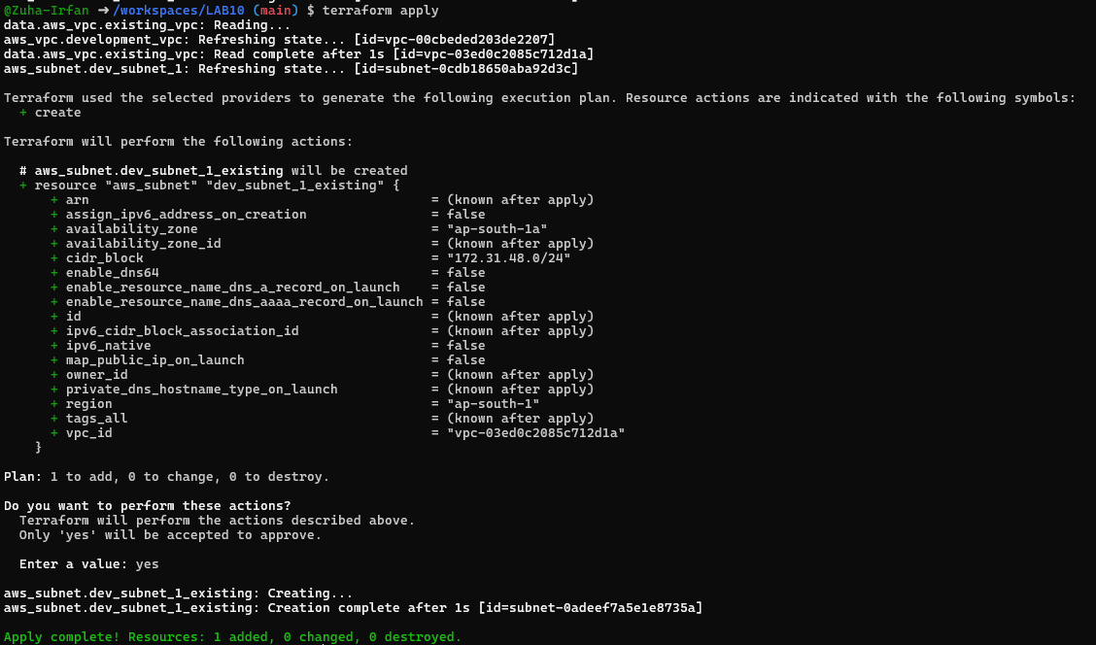
- task4_terraform_apply_after_refresh.png

- task4_terraform_destroy_all.png
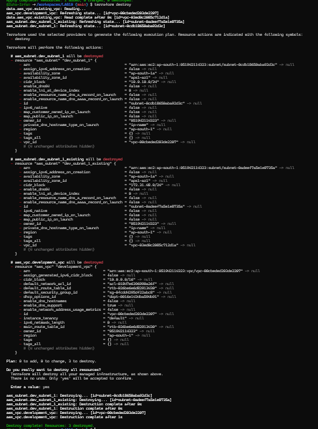

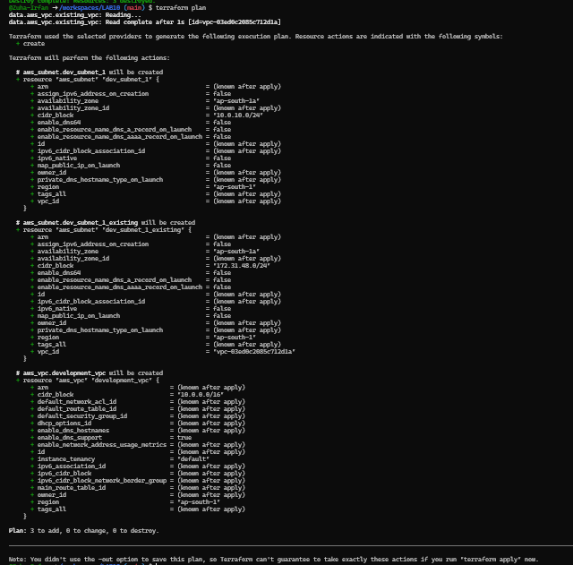
- task4_terraform_plan_output.png
- task4_terraform_apply_after_destroy.png
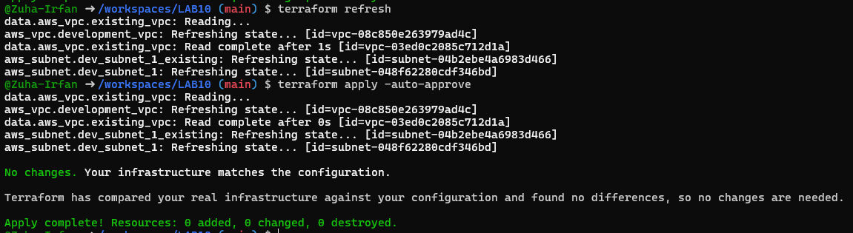

- task4_main_tf_tagging.png
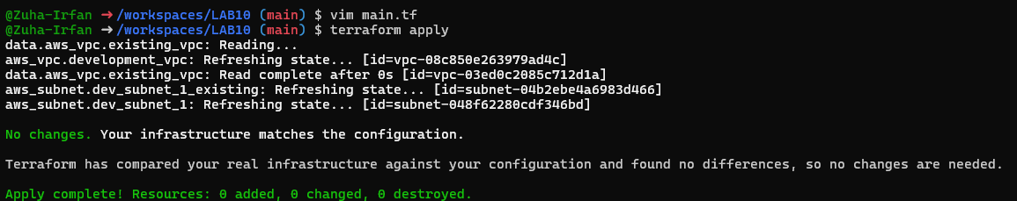

- task4_terraform_apply_tagging.png
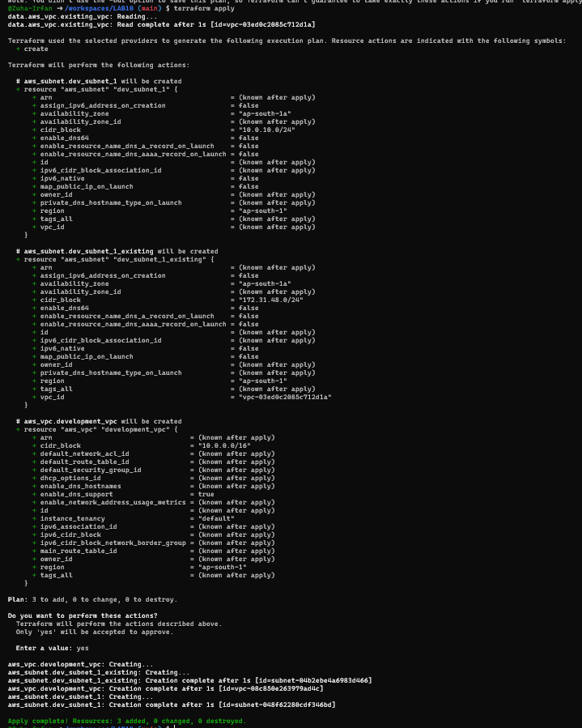

- task4_terraform_plan_remove_tag.png
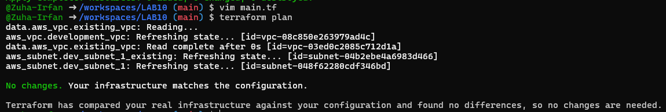

- task4_terraform_apply_remove_tag.png
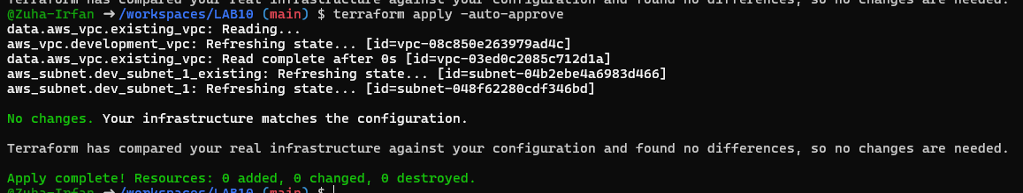

Task 5 — State File Inspection & Terraform State Commands
- task5_terraform_destroy.png
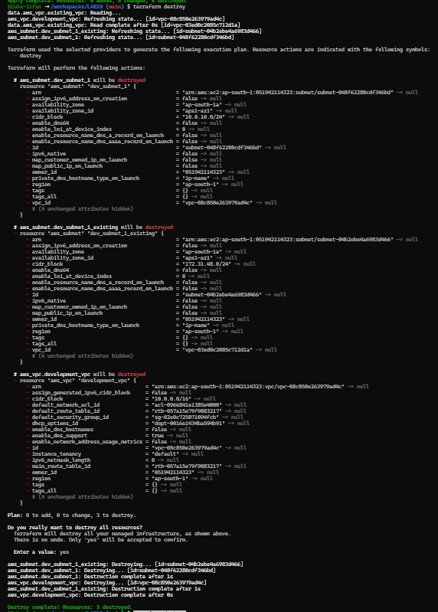
- task5_terraform_state_file_empty.png
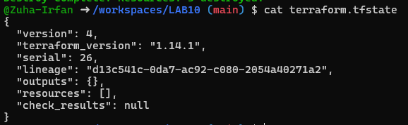

- task5_terraform_state_backup_prev.png
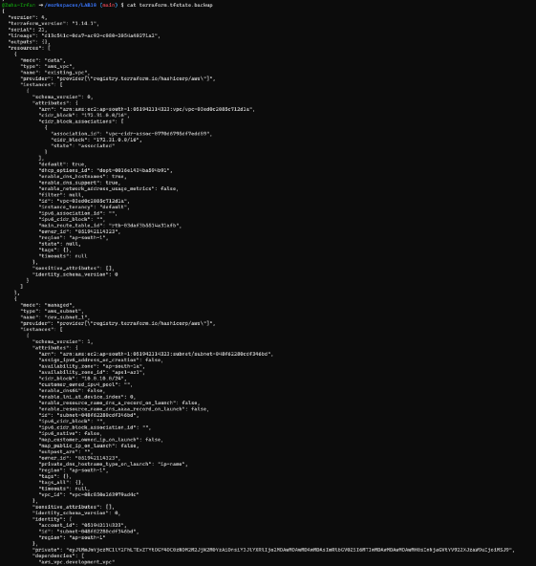
- task5_terraform_apply_recreated.png
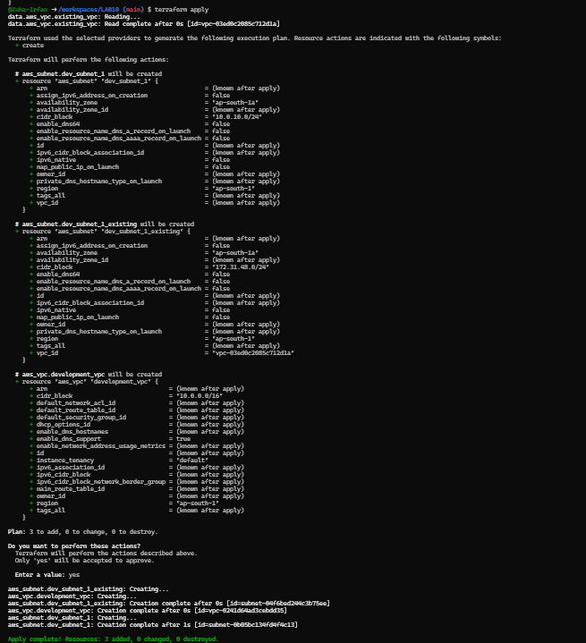

- task5_terraform_state_file_populated.png
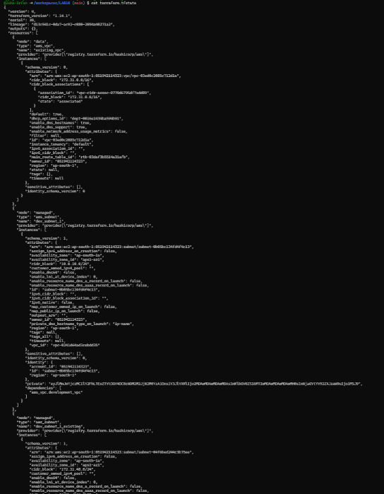
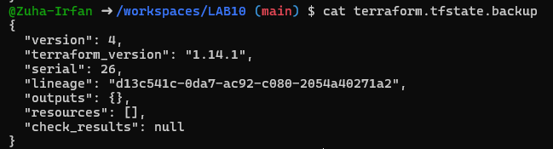
- task5_terraform_state_backup_empty.png

- task5_terraform_state_list.png
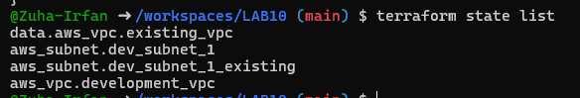
- task5_terraform_state_show_resource.png
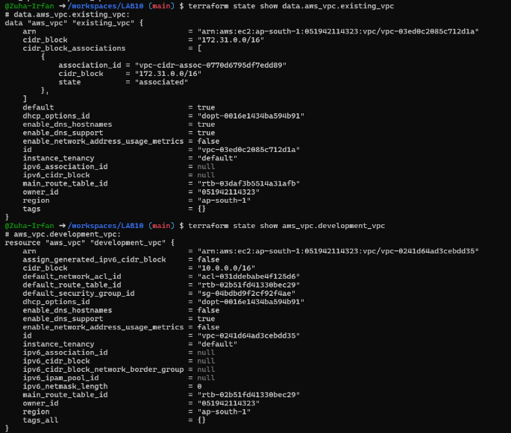

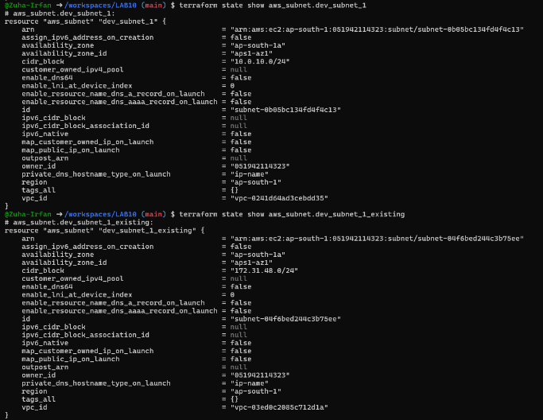

Task 6 — Terraform Outputs & Attributes Reporting
- task6_terraform_outputs_basic.png
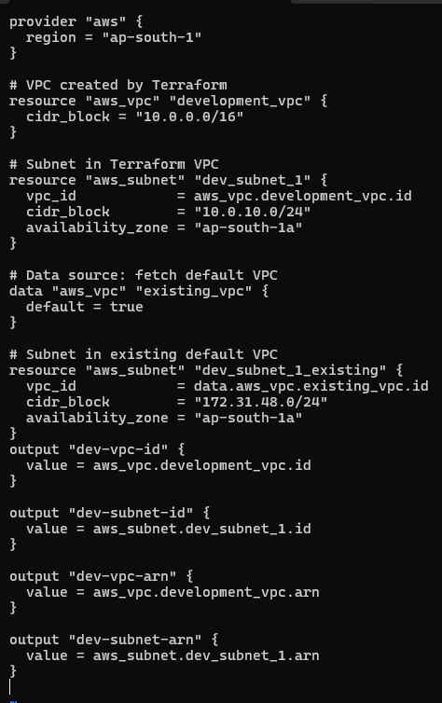

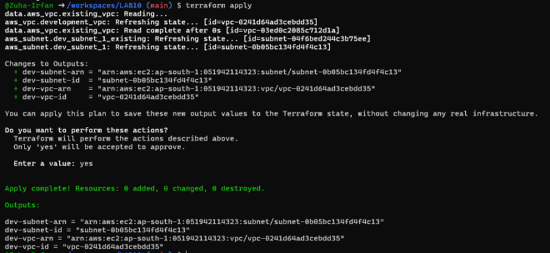

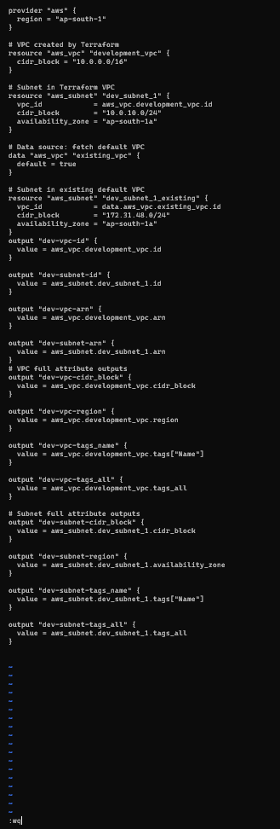
- task6_expanded_outputs.png

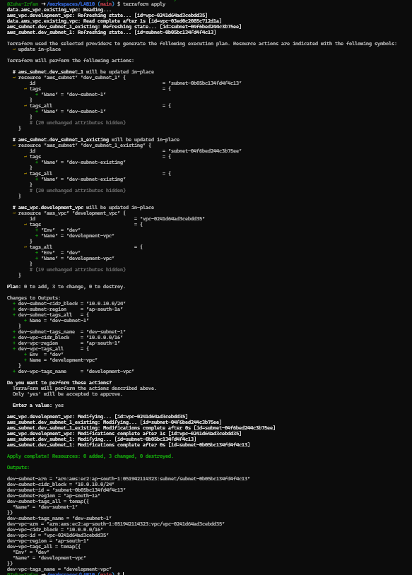

Cleanup — Delete Resources & State Verification
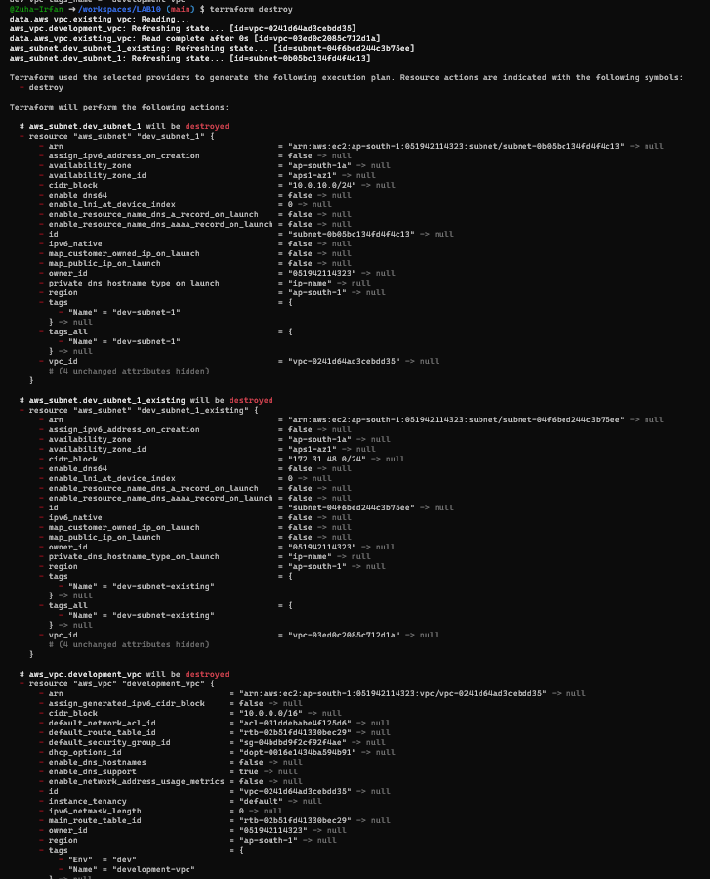
- cleanup_destroy_resources.png

- cleanup_state_files.png
